**MAHARAShTRA STATE BOARD OF TECHNICAL EDUCATION DEPARTMENT OF COMPUTER TECHNOLOGY**

**A**

**PROJECT REPORT**

**ON**

**“E-College system for blind students”**

**SUBMITTED TO**

**DEPARTMENT OF COMPUTER TECHNOLOGY**

**KAI.BHAUSAHEB HIRAY S.S.TRUSTS’S**

**K.B.H.POLYTECHNIC**

**MALEGAON CAMP**

**MALEGAON (NASHIK)**

**IN PRACTICAL FULFILLMENT OF THE REQUIREMENT FOR THE AWARD OF THE**

**DIPLOMA IN COMPUTER TECHNOLOGY**

**SUBMITTED BY**

**Miss. SHARVARI DINESH CHANDRATRAY (CM)**

**Miss. AISHWARYA NITESH SUPEKAR (CM)**

**Miss. URMILA DIGAMBAR NIKAM (CM)**

**Miss. NIKITA VIJAY SHEWALE (CM)**

**GUIDED BY**

**Mr. KEDA.S.PAWAR**

**(ACADEMIC YEAR: 2018-2019)**

**K.B.H.POLYTECHNIC S. S. TRUST’S, BHAYGAON ROAD, MALEGAON CAMP, MALEGAON (NASHIK)**

**CERTIFICATE**

**DEPARTMENT OF CIOMPUTER TECHNOLOGY**

**This is to certify that**

**Mr.Mohammad Hassan Mohammad Baquir (CM)**

**Mr.Shaikh Zubair Shaikh Rafeeque (CM)**

**Mr.Mushrif Shah (CM)**

**Mr.Tasir (CM)**

**of final year diploma student in computer technology has satisfactorily completed project entitled “Virtual Mouse Using Python” for academic year 2018-2019.**

Exam Seat No.: Date:

**Mr. K. S. Pawar**

(Project Guide) H.O.D.

CM DEPARTMENT

**Sign of External Principal**

**Mr. S. M. Khangal**

K.B.H.POLYTECHNIC MALEGAON (NASHIK)

**ACKNOWLEDGEMENT**

With deep sense of gratitude we would like to thanks all the people who have lit our path with their kind guidance .We are very grateful to these intellectuals who did their best to help us during the project work. It is our proud privilege to express deep sense of gratitude to **Prof. Mr. S. M. Khangal, Principal of K.B.H.Polytechnic, Malegaon**, for his comment and kind permission to complete this project. We remain indebted to **H.O.D. Mr. K.S. Pawar of our department** for their timely suggestion and valuable guidance.

The special guidance **Prof. K.S. Pawar of Computer and Information Technology Department** for their expensive, excellent and precious guidance in completion of this project.We thanks to all colleagues for their appreciable help for our working project.

We thankful to our **parents** who providing their wishful support for our project completion successfully.

And lastly we thanks to our all **friends** and the people who are directly or indirectly related to our project work.

**THANKS**

**Yours Truly,**

Mr.Mohammad Hassan Mohammad Baquir (CM)

Mr.Shaikh Zubair Shaikh Rafeeque (CM)

Mr.Mushrif Shah (CM)

Mr.Tasir (CM)

**ABSTRACT**

Virtual mouse using Python is a computer vision-based application that allows users to interact with their computer by tracking their hand movements. This technology has become increasingly popular due to its ease of use and accessibility. The aim of this project is to develop a virtual mouse that can be used as a substitute for a traditional physical mouse. The virtual mouse uses Python's OpenCV library for hand tracking and gesture recognition. The software works by tracking the user's hand and mapping it to a virtual cursor that moves in real-time on the computer screen. The user can then use hand gestures to perform actions such as clicking, scrolling, and dragging. The project has several advantages over traditional physical mice, including improved accessibility for people with disabilities and a reduced risk of repetitive strain injuries. This abstract discusses the implementation of the virtual mouse using Python and its potential applications.

**PROJECT INDEX**

|  |  |  |  |
| --- | --- | --- | --- |
|  | | | Page.no |
|  |  | Acknowledgement | 3 |
|  |  | Abstract | 4 |
|  |  | List of Figures | 6 |
|  |  | List of Tables | 6 |
| 1. | Introduction | | 7 |
|  | 1.1 | Introduction of Project | 8 |
|  | 1.2 | Detailed Problem Definition | 9 |
|  | 1.3 | Current Market Survey | 10 |
|  | 1.4 | Need Of The System | 11 |
|  | 1.5 | Feasibility Of The System | 12 |
|  | 1.6 | Organization of The Report | 13 |
| 2. | Analysis | | 14 |
|  | 2.1 | Project Plan | 14 |
|  | 2.2 | Requirement Analysis | 15 |
|  | 2.3 | Team Structure | 15 |
| 3. | Design | | 16 |
|  | 3.1 | Software Requirement Specification | 17 |
|  | 3.2 | Risk Assessment | 19 |
| 4. | Modeling | | 20 |
|  | 4.1 | UML diagram/ER diagram/DFDs | 21 |
| 5. | Methodology | | 29 |
|  | 5.1 | Software’s Used | 30 |
|  | 5.2 | Hardware Specification | 31 |
|  | 5.3 | Programming Language | 32 |
|  | 5.4 | Platform | 33 |
|  | 5.5 | Components | 34 |
|  | 5.6 | Tools | 35 |
|  | 5.7 | Methods and Procedures | 35 |
| 6. | Result | | 36 |
| 7. | Testing | | 39 |
|  | 7.1 | Formal Technical Reviews | 40 |
|  | 7.2 | Test Plan | 42 |
|  | 7.3 | Test Cases | 44 |
| 8. | Conclusion | | 45 |
| 9. | References | | 46 |
| 10. | Documentation | | 47 |

**LIST OF FIGURES**

|  |  |  |  |
| --- | --- | --- | --- |
|  | System Diagrams | | Page no. |
| 1. | 1.1 | E-R Diagram | 23 |
|  | 1.2 | Class Diagram | 24 |
|  | 1.3 | Use Case Diagram | 25 |
|  | 1.4 | Sequence Diagram | 26 |
|  | 1.5 | Component Diagram | 27 |
|  | 1.6 | Activity Diagram | 28 |
|  | 1.7 | Deployment Diagram | 28 |

**LIST OF TABLES**

|  |  |  |  |
| --- | --- | --- | --- |
|  | Tables | | Page no. |
| 1. | 1.1 | Project Plan | 14 |
|  | 1.2 | Risk Assessment | 19 |
|  | 1.3 | Test Plan | 42 |
|  | 1.4 | Test Cases | 44 |

**Chapter 1**

**INTRODUCTION**

**1.1INTRODUCTION OF PROJECT**

The virtual mouse using Python is a computer vision-based application that allows users to interact with their computer using hand gestures instead of a physical mouse. This project aims to develop a virtual mouse that can be used as a substitute for a traditional physical mouse. The virtual mouse utilizes Python's OpenCV library for hand tracking and gesture recognition.

The use of hand gestures as an input device has several advantages over traditional physical mice. Firstly, it provides a more natural and intuitive way of interacting with the computer. Secondly, it reduces the risk of repetitive strain injuries associated with prolonged use of a physical mouse. Additionally, it improves accessibility for people with disabilities who may have difficulty using a physical mouse.

The virtual mouse is implemented by tracking the user's hand using a camera and mapping the hand movements to a virtual cursor that moves in real-time on the computer screen. The user can then use hand gestures to perform actions such as clicking, scrolling, and dragging. The project involves the development of an algorithm for hand tracking and gesture recognition, as well as the integration of the virtual mouse with the computer's operating system.

The potential applications of the virtual mouse using Python are vast. It can be used in gaming, virtual reality, and augmented reality applications. Additionally, it has great potential in the medical field as a tool for people with disabilities to interact with computers more easily.

In summary, the virtual mouse using Python is a computer vision-based application that allows users to interact with their computer using hand gestures. The project aims to develop a virtual mouse that can be used as a substitute for a traditional physical mouse and has the potential to revolutionize the way people interact with computers.

**1.2PROBLEM DEFINITION**

The virtual mouse using Python addresses these limitations by providing an alternative input method that is more accessible and natural for users. It allows users to interact with their computer using hand gestures, eliminating the need for a physical mouse. Additionally, it reduces the risk of repetitive strain injuries associated with prolonged use of a physical mouse.

The problem definition of the virtual mouse using Python is to provide an alternative and improved input method for users that addresses the limitations of traditional physical mice. The project aims to develop a virtual mouse that is accessible, intuitive, and easy to use, while also reducing the risk of repetitive strain injuries.

**1.3MARKET SURVEY**

A market survey for the virtual mouse using Python shows that there is a growing demand for alternative input methods for computers, particularly for people with disabilities or those looking for a more natural way of interacting with their computer. The market survey includes the following findings:

1. Increased demand for accessibility: There is a growing demand for accessibility features in technology products, particularly for people with disabilities. The virtual mouse using Python addresses this need by providing an alternative input method that is more accessible than a traditional physical mouse.
2. Growing interest in natural user interfaces: Natural user interfaces, such as hand gestures, are becoming increasingly popular due to their intuitive nature. The virtual mouse using Python leverages this trend by providing a more natural and intuitive way of interacting with a computer.
3. Increased adoption of computer vision technologies: Computer vision technologies, such as the ones used in the virtual mouse using Python, are becoming more accessible and affordable. This is driving the adoption of these technologies in various applications, including alternative input methods for computers.
4. Potential for use in gaming and virtual reality: The virtual mouse using Python has the potential for use in gaming and virtual reality applications, providing a more immersive and natural way of interacting with these technologies.

Based on these findings, the market survey suggests that there is a significant market opportunity for the virtual mouse using Python, particularly in the accessibility and natural user interface segments. Additionally, there is potential for use in gaming and virtual reality applications.

**1.4NEED OF SYSTEM**

The virtual mouse using Python system fulfills the need for an alternative input method for computers that is more accessible, intuitive, and natural than traditional physical mice. The system addresses the following needs:

1. **Accessibility**: The virtual mouse using Python provides an alternative input method that is more accessible for people with disabilities, such as those with limited hand mobility or visual impairments.
2. **Natural user interface**: The system provides a more natural and intuitive way of interacting with a computer through hand gestures, eliminating the need for a physical mouse.
3. **Reduced risk of repetitive strain injuries**: Prolonged use of physical mice can lead to repetitive strain injuries, such as carpal tunnel syndrome. The virtual mouse using Python reduces this risk by providing an alternative input method that does not require repetitive hand movements.
4. **Mobility**: Traditional physical mice require a flat surface to operate, limiting their use in certain environments, such as while traveling. The virtual mouse using Python does not have this limitation and can be used in a variety of settings.

Overall, the virtual mouse using Python system fulfills the need for an alternative input method for computers that is accessible, intuitive, and reduces the risk of repetitive strain injuries. It provides a more natural and flexible way of interacting with a computer that is not limited by the need for a physical mouse.

**1.5FEASIBILITY OF SYSTEM**

The virtual mouse using Python system is feasible and has the potential for successful implementation.

**TECHNICAL FEASIBILITY** :-

The virtual mouse using Python system is technically feasible since it utilizes computer vision technologies, such as OpenCV, for hand tracking and gesture recognition. These technologies have been extensively researched and implemented in various applications.

**OPERATIONAL FEASIBILITY :-**

The system's operational feasibility is high since it is easy to use and does not require any specialized training. The virtual mouse using Python can be used by anyone who has basic computer knowledge and can operate a camera.

**ECONOMICAL FEASIBILITY :-**

The system's economic feasibility is reasonable since it does not require any expensive hardware components. The system only requires a camera and a computer, which are already widely available.

**LEGAL & REGULATORY FEASIBILITY :-**

The system does not violate any legal or regulatory requirements since it does not collect or store any user data. The virtual mouse using Python only uses a camera to track hand movements and gestures.

**1.6ORGANIZATIONAL REPORT**

We both the students successfully create this Project . The guide of our project supports us for developing the system effectively.

To implement this system we need information which is provided by Mr. K. S. Pawar sir which is our project guide as well as Subject teacher.

In chapter 1 we discuss he basic flow of the project, need of the system, feature of the system & future prospect of the system.

In chapter 2 we discuss the project plan requirement analysis & team structure.

In chapter 3 we discuss the Software Requirement Specification.

In chapter4 we discuss the UML diagram.

In chapter 5 we discuss software used hardware speciation, Programming language used, Platform, Components, tools, Methods &procedure.

In chapter 6 we discuss the result. In chapter 7 we discuss the Formal Technical reviews, Test plan, Test cases &Test results.

**Summary**

Hence we studied Project Definition, Current Market Survey, and need of the System, Feasibility of the Application , Future prospects & Organization of the report. In next chapter we will study project plan, requirement analysis & team structure.

**Chapter 2**

**ANALYSIS**

**2.1PROJECT PLAN**

|  |  |
| --- | --- |
| 1.Search for ideas | 2 week |
| 2.Finalizeation of project scope | 1 week |
| 3.Study of concept | 1 week |
| 4.Feasibility study | 1 week |
| 5.Study of system requirement | 1 week |
| 5.1 Study of Python | 2 week |
| 5.2 Study of Mysqli | 1 week |
| 5.3 Study of Modeling | 1 week |
| 6.Architecture Design | 1 week |
| 7.Model Design | 1 week |
| 8.Coding | 2 week |
| 9.Testing | 1 week |
| 9.1 Building test cases | 1 week |
| * 1. Test Review | 1 week |
| 9.3 Modification | 1 week |
| 10.Final Touchup | 1 week |
| 11.Deployment | 1 week |

**2.2REQUIREMENT ANALYSIS**

1. **Questionnaires :-**

We prepared questionnaires to get some information about the current Application . In final stage we used the questionnaires to get some numerical data that was required or missing after all the observation.

1. **Interviews :-**

The interviews were unstructured. We close some people in the organization who were either the decision-makers or users in some activity related with the project. We interviewed them many times. This helped us understand all the stages involved in any activity.

1. **Record Review :-**

This was the most beneficial activity for us while making the database. We studied the existing system structure, document used and generated in the organization.

1. **Observation :-**

While finding the fact or requirements of the system we kindly observe the existing system. We observe the existing structure, registers of different departments and also of student register.

The project team consist of 4 members, the effort assignment of team members are given above in the project table, the duties and details of each member is as below:

|  |  |  |
| --- | --- | --- |
| Name Of Team Member | Role | Email Id |
|  | Developer |  |
|  | Developer |  |
|  | Developer | - |
|  | Developer | - |
| Internal Guide |  | |

**Summary**

Hence we studied project plan, requirement analysis & team structure. In next chapter we will study software requirement specification of the report.

**Chapter 3**

**DESIGNING**

**3.1SOFTWARE REQUIREMENT SPECIFICATION**

* **Software Specification :-**

1. Android Studio
2. WAMP Sarver

**3.2RISK ASSESSMENT**

|  |  |  |
| --- | --- | --- |
| Risks | Observations | Risk assessment activities |
| Development Delay | Code drops from development going through constant slippage. | 1. To avoid development delay we have already preplan project work.  2. We have already preplanned implementation of project. |
| Show stopper defects | The test cycle gets suspended/resume often. | 1. Having clear exit criteria for development before a product can be accepted for testing. |
| Insufficient time for testing | Time spent on testing is a small fraction of the overall product life cycle. | 1. We had performed unit testing for each module.  2. We also performed white box testing. |
| Over cautiousness in testing | Insignificant defects getting reported.  Testing team becoming bottle neck for release. | 1.Main module such as console and graphical are tested. |

**Summary**

Hence we studied software requirement specification of the project. In next chapter we will study UML diagram/ER diagram/DFD’s.

**Chapter 4**

**MODELING**

**LIFE CYCLE MODEL**

There are many types of life cycle model, which are as follow:

1. Waterfall Model
2. Incremental Model
3. Prototyping Model
4. Spiral Model
5. RAD Model

Out of which we choose the Spiral Model

**Spiral Model:**

The main advantage of the Spiral model is it gives the core model at every round. In this model we also implements risk analysis phase.



**4.1UML DIAGRAM/E-R DIAFRAM**

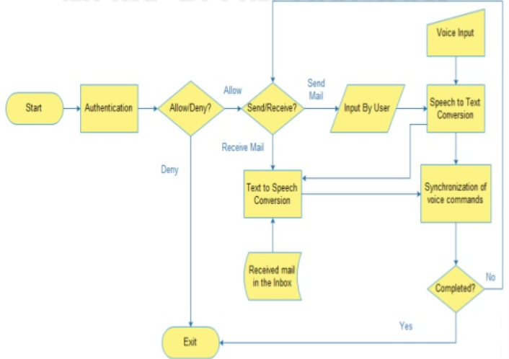

**CLASS DIAGRAM**

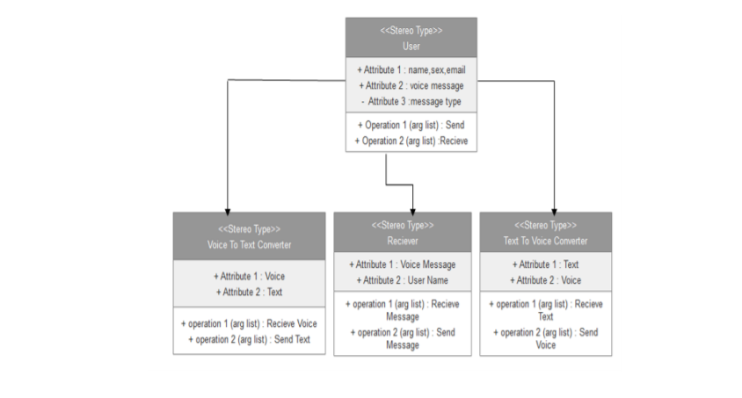

**USECASE DIAGRAM**

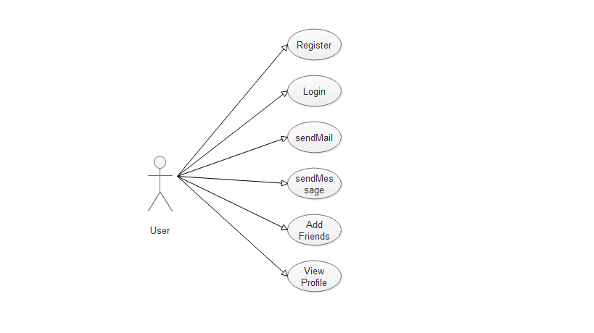

**SEQUENCE DIAGRAM**

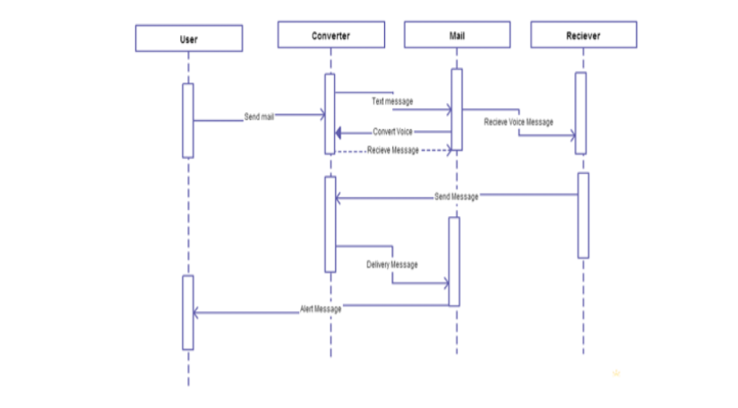

**COMPONENT DIAGRAM**

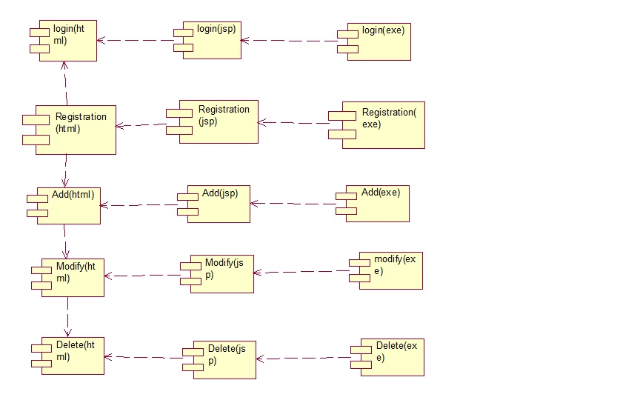

**ACTIVITY DIAGRAM**



**Summary**

Hence we study UML diagram/ER diagram. In next chapter we will study software used, hardware specification, programming language, Platform, components& tools.

**Chapter 5**

**METHODOLOGY**

**5.1SOFTWARE USE**

For development of this system we use various kinds of software.

We use a following type of software’s to build our ERP System Notepad++,Google chrome & WAMP server.

* **Android Studio:**
  1. Android Studio is the official integrated development environment for Google's Android operating system, built on JetBrains' IntelliJ IDEA software and designed specifically for Android development. It is available for download on Windows, macOS and Linux based operating systems
* **WAMP Server**:

1. WampServer is a Web development platform on Windows that allows you to create dynamic Web applications with Apache2, PHP, and MySQL. ... Best of all, WampServer is available for free (under GPML license) in both 32 and 64 bit versions.

**5.2HARDWARE SPECIFICATION**

* **Hardware Specification :-**

1. System
2. Network Devices
3. Pentium 2 Processor
4. 512 MB RAM
5. 40 GB HDD
6. Android Cellphone

**5.3PROGRAMMING LANGUAGE**

We used following languages in our Application **Android,XML,PHP** These languages help us for making our system **graphically** and **visually effective** for the user.

We used the **Mysqli** language for creating the database of the system.

The **XML** language is also used in our system to run the Application over the Internet.

**5.4 PLATFORMS**

We implement the **E-Collage Sytem for Blind Students Application** which is executed on Android Studio.To execute this system we need much Application and the platform used for this system is any windows OS like windows XP, windows 7 ,10etc.

**We used “windows XP” as a platform to this system.**

**5.5 COMPONENT**

We used many types of tools to implements this system.

This system is Android base so we need software which implements the Application.

We also used the Adobe Dream viewer for making our website lesscomplex and user friendly. Because of this our user will easily interact with the system, because of a graphical presentation (view).

* **Android Studio**:

The android developer tools let you create interactive and powerful application for android platform. The tools can be generally categorized into two types.

SDK tools

Platform tools

**5.6 TOOLS**

We used many types of tools to implements this system.

This system is web base so we need software which implements the website.

We also used the Adobe Dream viewer for making our website lesscomplex and user friendly. Because of this our user will easily interact with the system, because of a graphical presentation (view).

* **Dream viewer** :

1. Because of dream viewer our work effort will be reduced.
2. And we got a visualized effect to our site, better than the HTML.
3. Effort also compressed.
4. Time also saved.

**Chapter 6**

**Result**

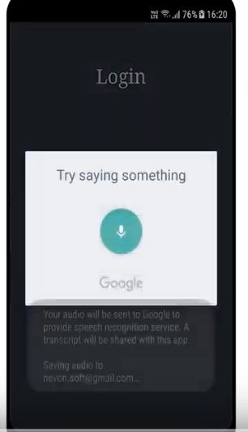

**LoginScreen**

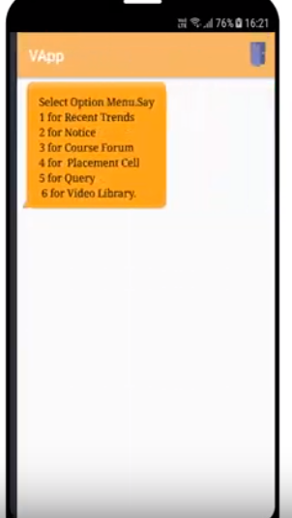

**InformationScreen**

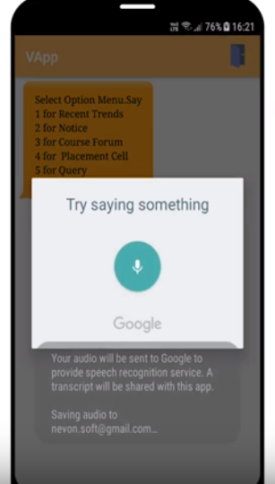

**InformationScreen**

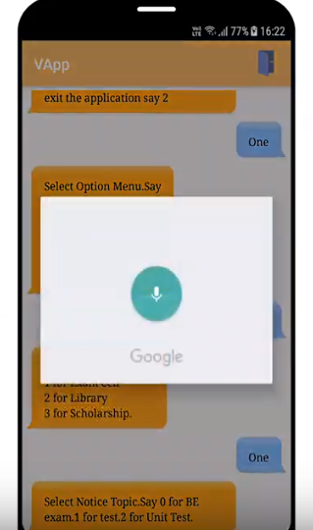

**ChatScreen**

**Summary**

In this chapter we actually implement our system using different software and tools.

**Chapter 7**

**TESTING**

**7.1 FORMAL TECHNICAL REVIEW**

**Testing plan**

The following methods of testing were carried out to check correctness and reliability of the processing system.

**Black-box Testing:**

The black-box testing is testing strategy, which does not need any knowledge of internal design or code etc. As the name suggests, no knowledge of internal logic or code structure is required.

There is no need of having detailed functional knowledge of system to the tester. The tests will be done from end user’s point of view. Also the testing helps to identify the vagueness and contradiction in the functional specifications, and that’s why we use this testing.

We have checked all graphics loads and checked they are display properly on web page or not. We have checked the text-boxes, list boxes and other fields for entering or selecting information.

* **Interface Testing**:

To assure that information properly flows out the program unit under test.

* **Data Structure:**

To assure that all variables are initiated properly and data is stored properly.

* **Independent Path Test:**

All independent paths through the module were executed at once to assure that they executes perfectly.

* **Boundary Test:**

Boundary value analysis is the technique of making sure that behavior of system is predictable for the input and output boundary conditions and it is important because defects could be introduced at the boundaries.

**Dynamic White-box Testing:**

In this testing method we gain from seeing what the code does and how it works to determine what to test, what not to test and how to approach the testing. In this testing we can see and use the underlying structure of the code to design and run the different tests. It also involves directly testing and controlling the software.

Testing the software at the top level, as the completed program, but adjusting the test cases based on what we know about the software’s operation.

Gaining access to read variables and state information from the software to help the user to determine whether our tests are doing what they thought.

**7.2 TEST PLAN**

The purpose of this test plan is to describe the testing practice used for development of

compiler and converter service provider and to identify the items to be test during this

project.

**Test Plan**

|  |  |  |
| --- | --- | --- |
| Sr. No. | Task | Activity |
| 1 | Preparation of test plan | The resource needed for testing our project are computer and human. |
| 2 | Scope Management | Optimization features of project are tested. |
| 3 | Deciding test approach /strategy | We perform unit testing and white box testing. |
| 4 | Setting up criteria for testing | If arguments are missing then file is not optimized and error message are display. |
| 5 | Identifying responsibility, staffing and training needs | We divide our work in all partners. Every member perform some action. |
| 6 | Identifying resource requirements | We check the machine configuration and tools used for system |
| 7 | Identifying test deliverable | We have designed test cases for each facilities that we have provided to the user. |
| 8 | Testing tasks | There are many test cases in our project which gives us better result. |
| 9 | Communication Managements | Decisions are taken with the help of communication in between project members and project Guide. |
| 10 | Risk managements | We have defined various risk that make effect on our project. |

**7.3 TEST CASES**

|  |  |  |  |  |  |
| --- | --- | --- | --- | --- | --- |
| Sr. No. | Description | Input Data | Expected Result | Actual Result | Status |
| 1. | For Blind Student Login | | | | |
| 1.1 | Speak UserName in UserName Field | UserName | It should Accept | Accepted | PASS |
| 1.2 | Speak UserName in UserName Field | Other than new UserName | Error message should be given | Error message given | PASS |
| 1.3 | Speak password in Password Field | Password | It should Accept | Accepted | PASS |
| 1.4 | Speak password in Password Field | Other than new password | Error message should be given | Error message given | PASS |
| 2 | For Blind Student Inforamation | | | | |
| 2.1 | Speak collage Sytem information | Collage Sytem | It should be Accept | Accepted | PASS |
| 2.2 | Speak collage incorrect information | Other than more information | Error message should be given | Error message given | PASS |
| 2.3 | Speak scholarships information | Take more menus and selecting one option | It should be Accept | Accepted | PASS |
| 2.4 | Enter a incorrect Option | Other than Selection Menu | Error message Speak | Error message given | PASS |

**Summary**

In this chapter we define the testing plan and implement actual testing on our project.

We also define all possible test cases of this system,when each project is implemented then to

check whether it is execute properly or not and it gives output as per the requirements.

**CONCLUSION**

## Finally the project is team work that should be completed by the coordination understanding and communication between the team members and the most important think is during working on project is a planning.

## So for getting desire result within the time limits. The project can be completed with proper planning.

## This has help us a great depth to team Android and concept of UML. In have tried to make the software as user friendly as possible so as efficient in the work.

We are thanks to all of them who provide us some help to complete this project. They provide vital role in completion of our Application . We thanks to our parents to gives better support to do this project.

## That’s it! we have successfully completed the online orientation for college Appliaction. We have learned about quite few different services available to us here at college website system and undoubtedly we will want to explore them further at us leisure.

**REFERENCES**

PHP Workshop arranged by our HOD was proved to be fruitfull for the same.

**WEBSITES**

* [www.nevoenprojects.com](http://www.nevoenprojects.com)
* [www.coderscion.com](http://www.coderscion.com)
* [www.google.com](http://www.google.com)
* [www.w3resource.com](http://www.w3resource.com)

**DOCUMANTATION OF PAGE**

|  |  |  |  |  |  |  |  |  |
| --- | --- | --- | --- | --- | --- | --- | --- | --- |
| **Report Documentation** | | | | | | | | |
| Report Code : DC-Project 2017-2018 | | | | Report Number:- 01 | | | | |
| Report Title : E-College Sytem for blind Student | | | | | | | | |
| **Address(Details) :- CM Department, K.B.H.Polytechnic, Bhaygaon Road,**  **Malegaon Camp, Tal-Malegaon, Dist-Nashik.**  **Pin Code :- 423203.** | | | | | | | | |
| **Name of the student :-** | |  |  | |  | |  | |
| **Exam Seat No :-** | |  |  | |  | |  | |
| **Address :-** | |  |  | |  | |  | |
| **Email Id :-** | |  |  | |  | |  | |
| **Roll No :-** | |  |  | |  | |  | |
| **Cell No :-** | |  |  | |  | |  | |
| **Year :-** 2019-2020  **Branch :-** COMPUTER TECHNOLOGY | | | | | | | | |
| **Keyword :- College,Social Networking,Internet.** | | | | | | | | |
| Type of Report File | **Report Checked By :** | | | Report Checked Date:- | | Subject Teacher | | Total Copies : |
| **Abstract:- Social Networking** describes the phenomena found in, participatory and self-expressive Mobile Application—such as YouTube, MySpace, Facebook— where members/participants expose, discuss, reveal, and expound on their personal lives, activities, hopes, dreams, and even fantasies for others to see and marvel upon. | | | | | | | | |